CCCHC Hiking Club

HIKING NOTICE FOR SEPTEMBER 20, 2015

Dear Club Members:

For the hiking on 9/20/2015, we will simply hike along a majority of the trails on the hill between Eckley Pier and Port Costa. Fig. 1 illustrates the direction to the meeting place at Eckley Pier and a map of the hiking trails. The trails are not paved, and the average level of difficulty is about 2-1/2 to 3 out of 5. We pray that the breeze from the strait could help cool down our hiking sufficiently because only about 1/4 of the trails are shaded. Total distance of the hike measures about 4.5 miles round trip, and the walk takes about 2 to 2-1/4 hours. One 1-person restroom is available at the starting point, and another one at the entrance to the Bull Valley Staging which is very close to the hiking trails. No restroom facility is available at the turning mid point of the hiking.

There are a couple of picnic tables at the far end of the green patch at the starting point, and they are available on a first-come-first-serve basis. The pier is along the shore and also close to the green patch. Please bring your own lunch if you plan to join the group for a picnic luncheon at the end of our hiking.

Date/Time: Sunday, 9/20/2015, at 9:30 a.m.

Gathering Place: Edge of the green patch located at the bottom end of the long driveway after you make a right turn at the "Bull Valley Staging and Eckley Pier" sign from the Carquinez Scenic Drive.

Direction: On Hwy 4 either West bound or East bound, take the "Mc Ewen Rd/Port Costa" exit. Go north towards Port Costa. Drive carefully because the road is winding. After about 2 to 3 miles, you come to a stop sign at the intersection (Point A) of Mc Ewen Rd with Carquinez Scenic Drive and Reservoir St. See Fig. 1 for an illustration of the intersection. Make a left turn onto the very winding Carquinez Scenic Drive towards Crokett (West bound) and go another 1 mile. Make a right turn onto the long driveway at the sign of "Bull Valley Staging & Eckley Pier" (see Fig. 2 for a picture of the sign).

Things to Bring: Standard equipment such as hat, warm clothes, sunglasses, water, snacks.

Lunch: Do not forget the lunch if you plan to join the group for a picnic luncheon at the end of the hiking.

Please direct any questions you may have to Tom Tsai, either by email to nien.tsai@astound.net or by phone at 925-296-0471 (home).

Looking forward to seeing you there.

Sincerely,

Tom Tsai

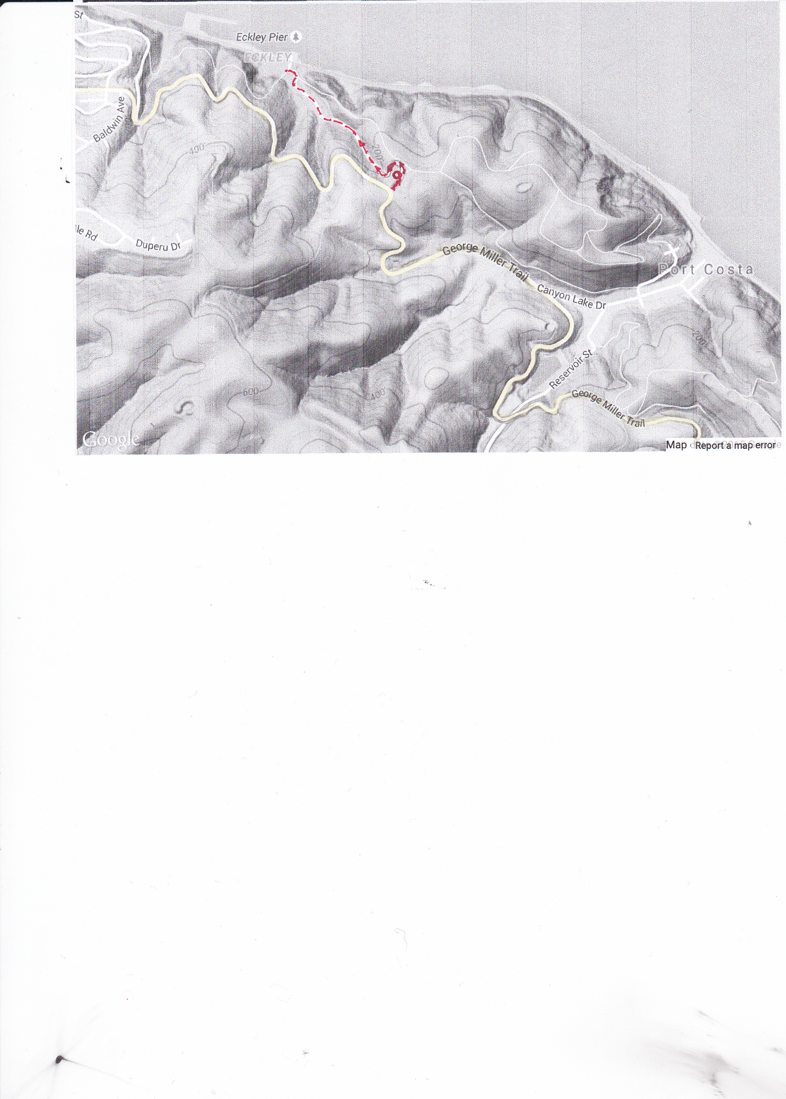
Meet at End of Road.
Sign of "Bull Valley Staging & Eckley Pier" (See Fig. 2)
Eckley Pier
Port Costa
Carquinez Scenic Drive
Mc Ewen Rd
(from Hwy 4)
Crockett
A
Reservoir St.
Mc Ewen Rd
Carquinez Scenic Dr
A
B
= 1-Person Man/Women
Restroom

= Water Faucet
Gate = Turning Point
Intersection at A
CARQUINEZ STRAIT
Fig. 1 Direction to Eckley Pier & Hiking Trail Map
Legends

1-Person Restroom

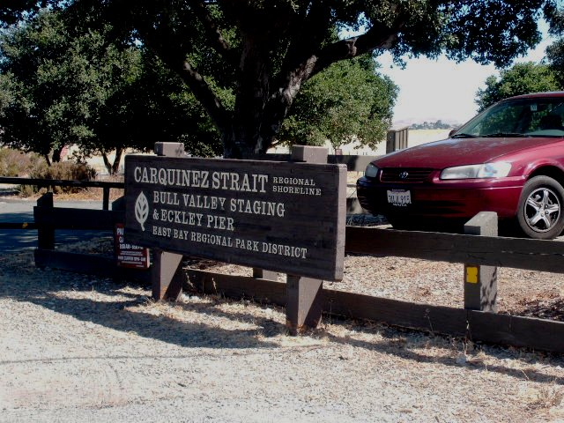

Fig. 2 Sign "Bull Valley Staging & Eckley Pier"
Along Carquinez Scenic Drive Westbound

